Experiment-2
Name: -G. Akshya Regno: -192425132
Course Code: -MLA0305 Slot-B

Title: - Reinforcement Learning framework using a Markov Decision Process (MDP)
AIM: - To implement a Reinforcement Learning framework using a Markov Decision Process (MDP) and demonstrate the interaction between an agent and environment through states, actions, transitions, and rewards using Q-Learning.
PROCEDURE
- Import the required Python libraries such as NumPy, Pandas, Matplotlib, and Scikit-learn.
- Generate a synthetic dataset using the Gaussian Mixture Model (GMM).
- Generate 500 records containing:
- Display the first 10 samples of the generated dataset.
- Calculate and display the dataset summary containing minimum, maximum, mean, and standard deviation.
- Save the generated dataset as a CSV file and provide an option to download it.
- Define the MDP states from 0 to 9.
- Define four possible actions:
- Define the transition function to determine the next state and reward for each state-action pair.
- Initialize the Q-table with zeros.
- Set the Q-Learning parameters:
  - Learning rate, α = 0.10
  - Discount factor, γ = 0.90
  - Exploration rate, ε = 0.20
- Train the Q-Learning agent for 500 episodes.
- Use the ε-greedy policy to balance exploration and exploitation.
- Update the Q-values using the Q-Learning Bellman equation:
Q(s,a)=Q(s,a)+α[r+γmaxQ(s′,a′)−Q(s,a)]
- Generate and display the learned Q-table.
- Determine the optimal action/policy for each state.
- Run the trained agent through the MDP environment and record its state path and rewards.
- Create a random agent and evaluate its performance.
- Compare the random agent and trained Q-Learning agent using average, maximum, and minimum rewards.
- Generate visualizations for: GMM reward distribution, Q-Learning training performance, Steps taken during training, Q-table heatmap, Random agent vs trained agent comparison
- Display the final summary table and performance results.

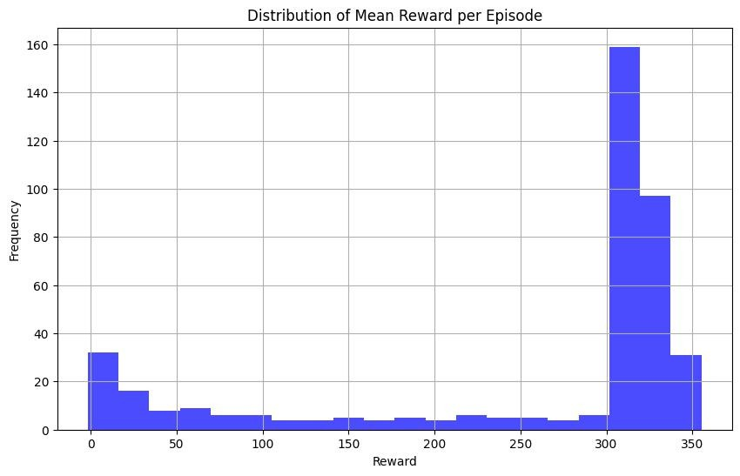
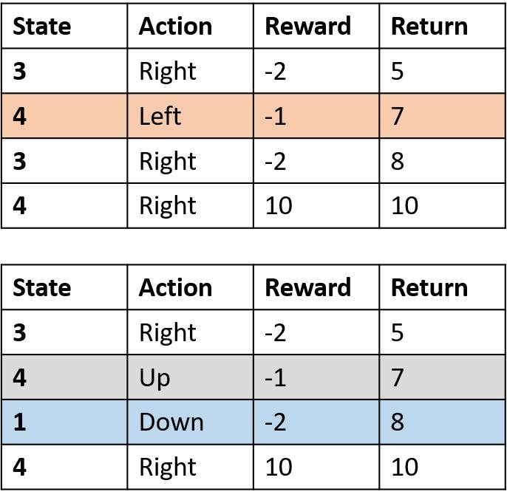

Fig: -1 Mean Reward per Episode

Fig: -1 Mean Reward per Episode

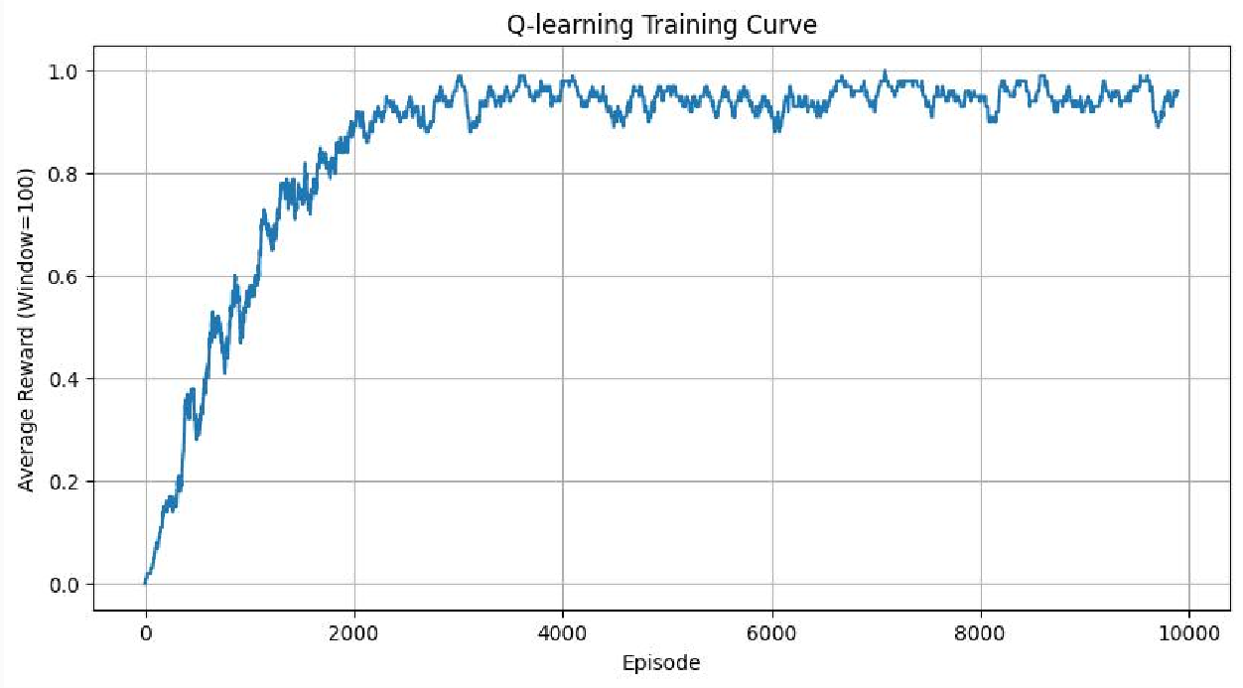
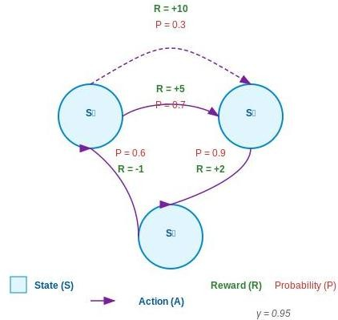

Fig: -4 Q Learning Curve
RESULT

The Reinforcement Learning framework and Markov Decision Process were successfully implemented using Q-Learning.

